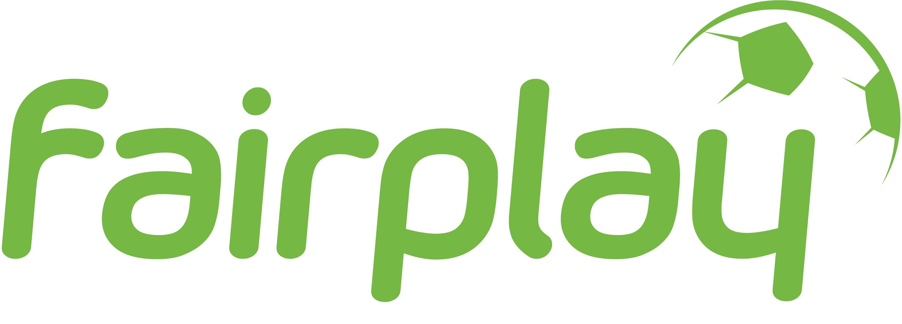

Application Form
Event – European Week of Sport (EWoS)

Title of the Event
Initiative | Organisation
Contact Person

Address
Mobil
E-Mail
Website
Planned Date of the Event
Target Group of the Action

Short description of the planned Activities (date, place, programme,…)

Who are Partners in your event?
expected number of participants
support expected from SWR-project (financial support, materials, workshops,…)
List for what you plan to use potential financial support of SWR-project

(please note: no costs for alcoholic drinks can be refunded)

Submission
Please send the filled application form via e-mail to fairplay@vidc.org or via post to fairplay, Möllwaldplatz 5/3, 1040 Wien, till 1st September 2017.
After your application we will get in contact with your organisation.

fairplay Initiative
Sport Welcomes Refugees
Kurt Wachter & David Hudelist
fairplay–VIDC
Möllwaldplatz 5/3, 1040 Wien

T: +43/1/7133594-64
F: +43/1/7133594-73
E-Mail: fairplay@vidc.org

